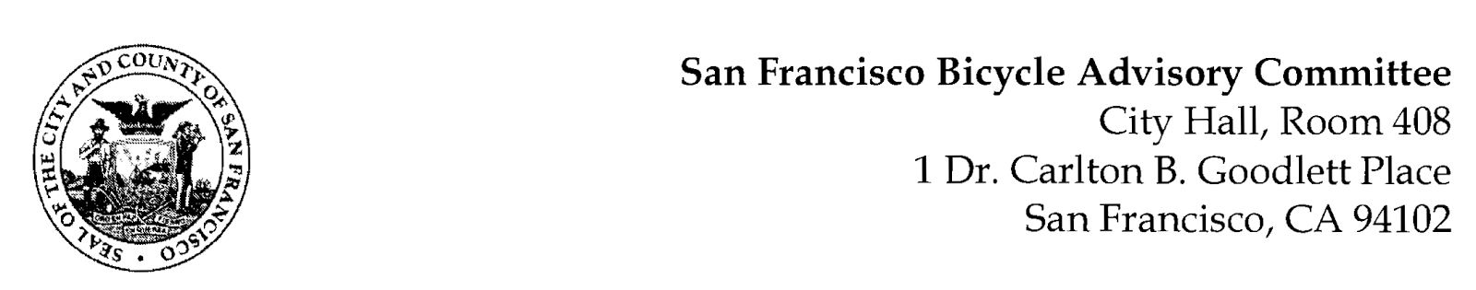 <https://www.facebook.com/events/1581490539262718/1581490572596048/>

**MEETING AGENDA**

**Monday, August 26 at 6:30pm**

Members: District 1 – Ms. Kristin Tieche – (Vice Chair), District 2 – Ms. Whitney Ericson, District 3 – Ms. Vanessa Day, District 4 – Mr. Joshua Kelly, District 5 – Ms. Melyssa Mendoza (Secretary), District 6 – Ms. Mary Kay Chin, District 7 – Mr. Bert Hill (Chair), District 8 – Ms. Diane Serafini, District 9 – Mr. Brandon Powell, District 10 – Mr. Paul Wells, District 11 – Mr. Jeffrey Taliaferro

**ORDER OF BUSINESS**

1. **Roll Call** – Determination of Quorum
2. **Ramaytush Ohlone Land Acknowledgement**
3. **Approve Minutes** – Monday, July 22, 2024 Meeting
4. **Public Comment** (*Discussion*)

The public may address the Committee on any matter within the jurisdiction of the Committee. This should not relate to any item on this agenda since the Committee will take public comment after it discusses and before voting on each agenda item. The Committee requests that speakers limit themselves to three minutes.

1. **Committee Reports & Administrative Business** (*Information*)
   1. District Committee Member Reports
2. **Governmental/Organizational/Committees** (*Discussion*)
   1. MTA Program Report – Jean Long & Lydon George
   2. SFPD – Captain Shields, the Captain of the Traffic Company
   3. SF Public Works - Clinton Otwell
   4. Bay Wheels – Joshua Johnson
   5. BART Bicycle Advisory Task Force –Jon Spangler, Maya Chaffee
3. **Proposal for Separated Bike Lanes on Dr. Carlton B. Goodlett** (*Presentation*)**-** Matt Lasky

Livable Streets is working on separated bike lanes on Dr. Carlton B Goodlett Place in front of City Hall between McAllister and Grove. The Mayor’s Office would like to implement this before January 2025.

1. **Resolution in Support of the SFMTA Transportation Development Act Article 3 Request for Fiscal Years 2023-24 and 2024-25 –** (*Resolution*) Drew Taplin

The SFMTA seeks approval from the BAC regarding plans to submit a claim coming from combined Fiscal Years 2024 and 2025 Transportation Development Act, Article 3 (TDA) funds to the MTC for the construction of the 13th Street Safety Project.

1. **Resolution Draft** (*Presentation*) **–** Diane Serafini

Proposing the City and County of San Francisco replace all plastic posts or bollards, delineating a protected bike lane, with metal ones or posts and bollards that have the capacity to prevent vehicles from entering a protected bike lane.

1. **Adjournment**.