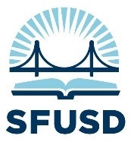
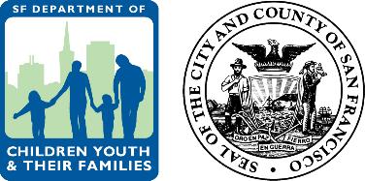
SFUSD / DCYF Student Success Grant Application
Readiness Grant Questions
(recommended word count ~300 per each response)

APPLICANTS: Please complete all fields on this application. When you are ready to submit, please use the link at the bottom of this form to upload to DCYF.

APPLICANT CAMPUS: | [RESPONSE]
SUBMITTER NAME: | [RESPONSE] | ROLE: | [RESPONSE]
PHONE: | [RESPONSE] | EMAIL: | [RESPONSE]

- Why are you interested in becoming a community school and how will it help you align with the district goals and guardrails?

[RESPONSE]

- What do you hope will change for your students and for your school community as a result of becoming a community school?

[RESPONSE]

- How do you see becoming a community school changing the way you work with partners (e.g. CBOs, community members)?

[RESPONSE]

- Where are you in the process of identifying a Community School Coordinator*? What role do you see them playing as part of your school leadership team and school community?

[RESPONSE]

- How will you engage your community in creating a Community Schools plan? Including how you will share leadership with community stakeholders.

[RESPONSE]

- What challenges do you anticipate in developing your plan and how might you mitigate them?

[RESPONSE]

- Please submit a budget for how you intend to use these funds. Please include a narrative of how these funds relate to your CCSP funds or other existing community schools budget if applicable.
[BUDGET NARRATIVE ]
*A Community Schools Coordinator must be a full time role responsible for completing the hopes and need assessment, coordinating the community schools leadership team, developing the implementation plan and completing any reporting requirements related to community schools.

Please submit this completed Readiness Grant Application and additional required Student Success Fund grant application items to DCYF via this link.

