How to Create a Non-Purchasing (NP) Purchase Order

Step 1: Open a new PO
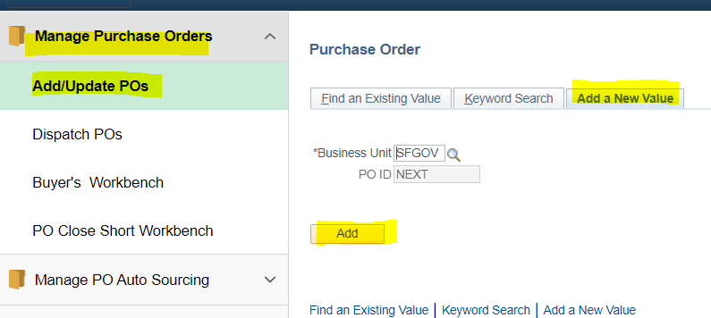
3
4
1
2
Step 2: Click on the PO Header to open a dialogue box.
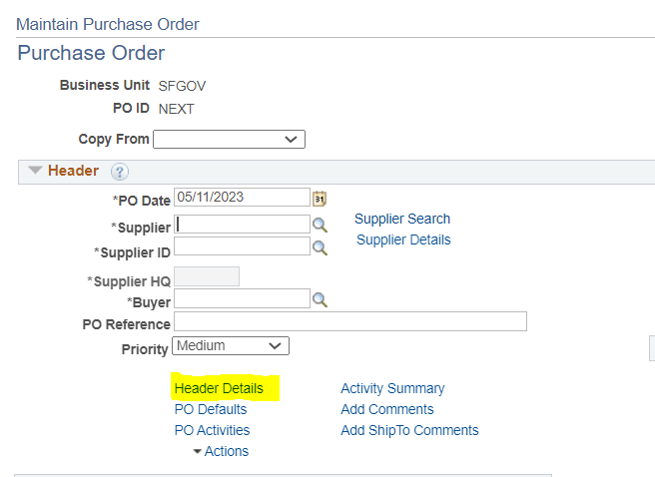
51
Step 3: When the dialogue box opens, enter “NP” into the “PO Type” field. Close box.
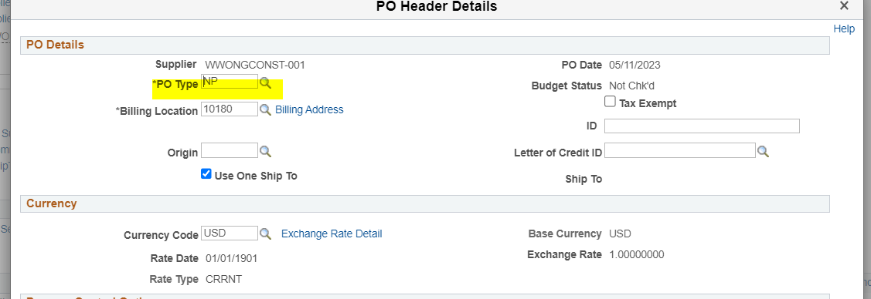
61
Step 4: In the PO, enter “NP” into the PO “Purchasing Authority” field.
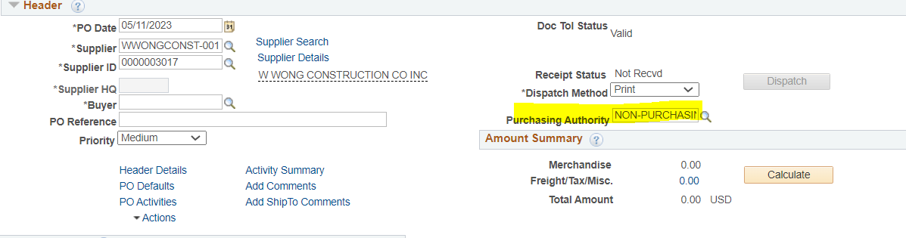
71

