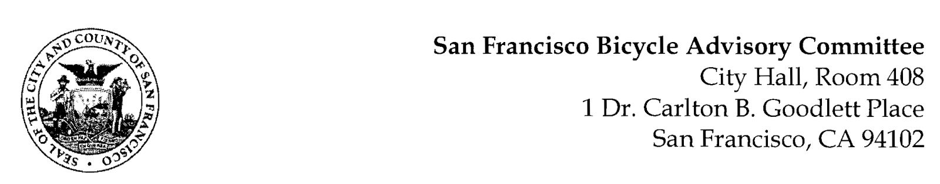
https://fb.me/e/3pi2XvJ7x
MEETING AGENDA
Monday, January 22, 2024 at 6:30pm

Members: District 1 – Ms. Kristin Tieche – (Vice Chair), District 1 – Open, District 2 – Ms. Whitney Ericson, District 3 – Open, District 4 – Mr. Joshua Kelly, District 5 – Ms. Melyssa Mendoza (Secretary), District 6 – Ms. Mary Kay Chin, District 7 – Mr. Bert Hill (Chair), District 8 – Ms. Diane Serafini, District 9 – Mr. Brandon Powell, District 10 – Mr. Paul Wells, District 11 – Mr. Jeffrey Taliaferro
ORDER OF BUSINESS
- Roll Call – Determination of Quorum
- Ramaytush Ohlone Land Acknowledgement
- Approve Minutes – Monday, October 23, 2023 (Delayed to January 22, 2024) & December 11, 2023 Meeting
- Public Comment (Discussion)
The public may address the Committee on any matter within the jurisdiction of the Committee. This should not relate to any item on this agenda since the Committee will take public comment after it discusses and before voting on each agenda item. The Committee requests that speakers limit themselves to three minutes.
- Committee Reports & Administrative Business (Information)
  - District Committee Member Reports
- Governmental/Organizational/Committees (Discussion)
  - MTA Program Report – Jean Long
  - SF Bicycle Coalition – Rachel Clyde
  - SF Public Works - Clinton Otwell
  - BART Bicycle Advisory Task Force –Jon Spangler
- Discussion of Expanding our Bicycle Mandate to Include other Active Transportation Entities e.g., Pedestrian, Senior & Disabled Communities
- Adjournment.

