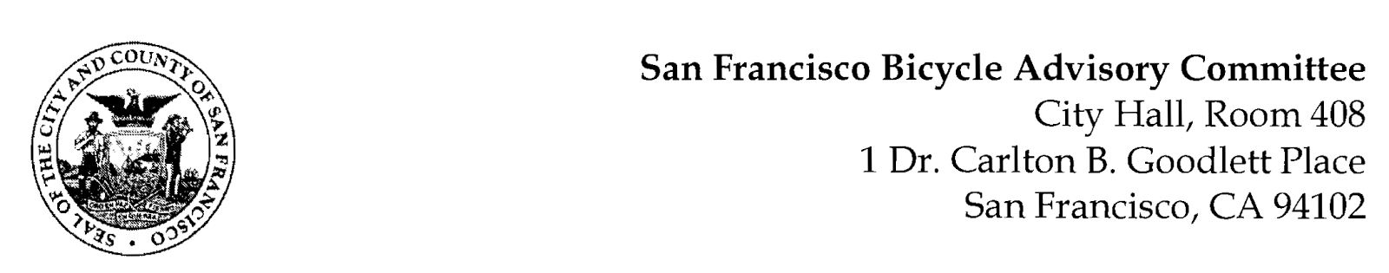
https://www.facebook.com/events/299093536403558/
MEETING AGENDA
Monday, October 23, 2023 at 6:30pm

Members: District 1 – Ms. Kristin Tieche – (Vice Chair), District 2 – Ms. Whitney Ericson, District 3 – Open, District 4 – Mr. Joshua Kelly, District 5 – Ms. Melyssa Mendoza (Secretary), District 6 – Ms. Mary Kay Chin, District 7 – Mr. Bert Hill (Chair), District 8 – Ms. Diane Serafini, District 9 – Mr. Brandon Powell, District 10 – Mr. Paul Wells, District 11 – Mr. Jeffrey Taliaferro
ORDER OF BUSINESS
- Roll Call – Determination of Quorum
- Ramaytush Ohlone Land Acknowledgement
- Approve Minutes – Monday, September 25, 2023
- Public Comment (Discussion)
The public may address the Committee on any matter within the jurisdiction of the Committee. This should not relate to any item on this agenda since the Committee will take public comment after it discusses and before voting on each agenda item. The Committee requests that speakers limit themselves to three minutes.
- Committee Reports & Administrative Business (Information)
  - Chairman's Report – Status of Legislative Bills
  - District Committee Member Reports
- Governmental/Organizational/Committee Reports (Discussion)
  - MTA Program Report – Christopher Kidd – Active Communities Plan Status
  - SF Bicycle Coalition – Rachel Clyde
  - SF Public Works - Clinton Otwell
  - BART Bicycle Advisory Task Force –Jon Spangler
- Arguello Safety Project Update - Matt Lasky of SFMTA (Presentation): Matt Lasky will provide an update to bicycle safety improvements on Arguello Boulevard and share existing conditions information for the corridor regarding some issues they are working through.
- SFMTA Request for State Transportation Improvement Program –Joel Goldberg (Presentation) Funding for Bus & Trolley Midlife Overhauls.
- Adjournment.

