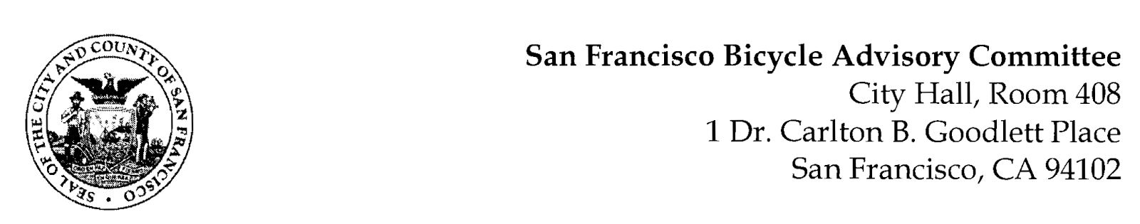
https://www.facebook.com/events/3604169709840228/
MEETING AGENDA
Monday, September 25, 2023 at 6:30pm

Members: District 1 – Ms. Kristin Tieche – (Vice Chair), District 2 – Ms. Whitney Ericson, District 3 – Open, District 4 – Mr. Joshua Kelly, District 5 – Ms. Melyssa Mendoza (Secretary), District 6 – Ms. Mary Kay Chin, District 7 – Mr. Bert Hill (Chair), District 8 – Ms. Diane Serafini, District 9 – Mr. Brandon Powell, District 10 – Mr. Paul Wells, District 11 – Mr. Jeffrey Taliaferro
ORDER OF BUSINESS
- Roll Call – Determination of Quorum
- Ramaytush Ohlone Land Acknowledgement
- Approve Minutes – Monday, August 28, 2023
- Public Comment (Discussion)
The public may address the Committee on any matter within the jurisdiction of the Committee. This should not relate to any item on this agenda since the Committee will take public comment after it discusses and before voting on each agenda item. The Committee requests that speakers limit themselves to three minutes.
- Committee Reports & Administrative Business (Information)
  - Chairman's Report – Status of Legislative Bills
  - District Committee Member Reports
- Governmental/Organizational/Committee Reports (Discussion)
  - MTA Program Report – Christopher Kidd – Active Communities Plan Status
  - SF Bicycle Coalition – Rachel Clyde
  - SF Public Works - Clinton Otwell
  - BART Bicycle Advisory Task Force –Jon Spangler
- Adjournment.

