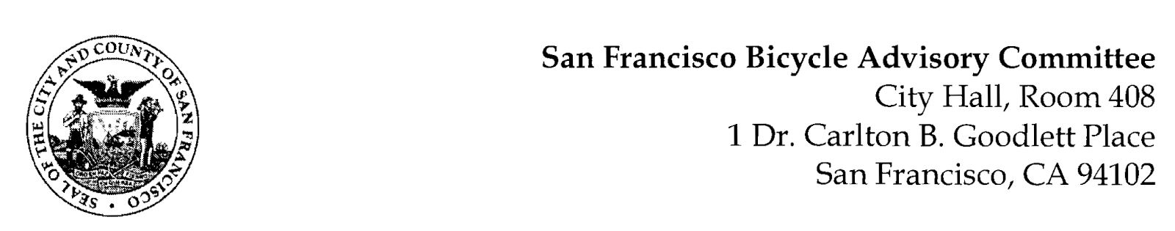

https://www.facebook.com/events/786972242748046/

MEETING AGENDA
Monday, May 22, 2023 at 6:30pm
Members: District 1 – Ms. Kristin Tieche – (Vice Chair), District 2 – Whitney Ericson, District 3 – Open, District 4 – Joshua Kelly, District 5 – Ms. Melyssa Mendoza (Secretary), District 6 – Ms. Mary Kay Chin, District 7 – Mr. Bert Hill (Chair), District 8 – Ms. Diane Serafini, District 9 – Mr. Brandon Powell, District 10 – Mr. Paul Wells, District 11 – Mr. Jeffrey Taliaferro
ORDER OF BUSINESS
- Roll Call – Determination of Quorum
- Ramaytush Ohlone Land Acknowledgement
- Approve Minutes – Monday, March 27, 2023
- Public Comment (Discussion Item)
The public may address the Committee on any matter within the jurisdiction of the Committee. This should not relate to any item on this agenda since the Committee will take public comment after it discusses and before voting on each agenda item. The Committee requests that speakers limit themselves to three minutes.
- Committee Reports & Administrative Business (Information)
  - Chairman's Report – Status of SB 645; Hearing Room Status
  - District Committee Member Reports
- Governmental/Organizational/Committee Reports (Discussion Item)
  - MTA Program Report – Jean Long (Valencia Quick Build, Better Market Street)
  - SF Bicycle Coalition – Rachel Clyde
  - SF Public Works - Clinton Otwell
  - BART Bicycle Advisory Task Force –Jon Spangler
  - Bay Wheels - TBD
- Preliminary Plan for Arguello Boulevard – Jamie Parks, MTA
- Active Communities Plan – Christopher Kidd
- Educational Information on MUNI Buses, Billboards, & Light Posts - (Presentation) Diane Serafini – This amount of coverage will reach all road users in San Francisco. Doing so will make it easier for all road users, people on foot, people on bikes and people in vehicles, to safely adapt to the new circumstances.
- Adjournment

