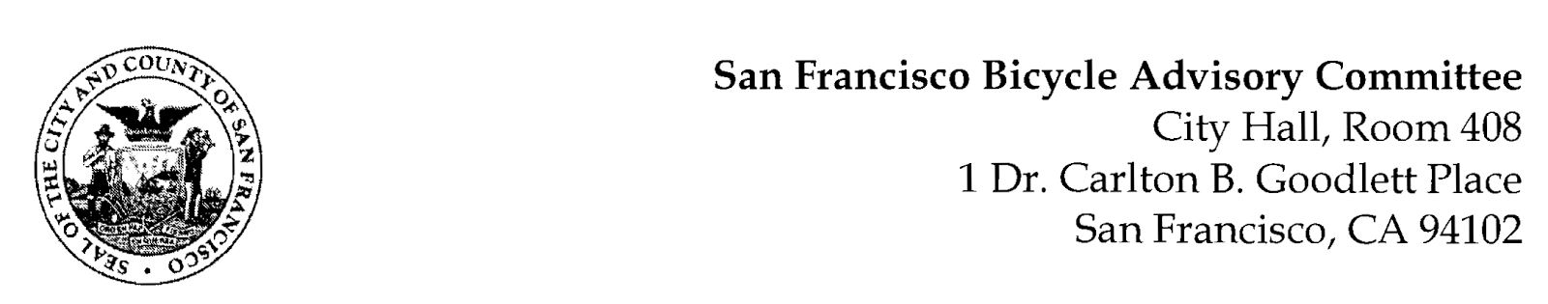

https://www.facebook.com/events/186159347551200/
MEETING AGENDA
Monday, April 17, 2023 at 7:00pm
Members: District 1 – Ms. Kristin Tieche- (Vice Chair), District 2 – Whitney Ericson, District 3 – Mr. Marc Brandt, District 4 – Joshua Kelly, District 5 - Ms. Melyssa Mendoza (Secretary), District 6 – Ms. Mary Kay Chin, District 7 – Mr. Bert Hill (Chair), District 8 – Ms. Diane Serafini, District 9 – Mr. Brandon Powell, District 10 – Mr. Paul Wells, District 11 – Mr. Jeffrey Taliaferro
ORDER OF BUSINESS
- Roll Call – Determination of Quorum
- Ramaytush Ohlone Land Acknowledgement
- Public Comment (Discussion Item)
The public may address the Committee on any matter within the jurisdiction of the Committee. This should not relate to any item on this agenda since the Committee will take public comment after it discusses and/or before voting on each agenda item. The Committee requests that each person limit themselves to three minutes.
- AB645 (Friedman) - (Resolution) Bert Hill – On April 17, Assembly Bill 645 will be discussed in committee. The bill would allow identified communities in California to participate in a pilot program to enforce speed limits on designated streets by use of a camera that records excessive speeds and the license plate of the vehicle. Endorsement of this resolution would allow testimony at the hearing that the San Francisco BAC endorses passage of the Bill.
- Adjournment

