PROPOSAL NARRATIVE QUESTIONS
The proposal narrative should not exceed 6 total pages. MOHCD will not accept any handwritten narratives. Font size must be at least 12 point. Pages must be standard 8-1/2 by 11.

- Project Design and Project Readiness (up to 30 points)
- Describe your project, including which programs benefit from it, and a description of the target populations and the neighborhoods the programs serve.
- Describe how your project meets one or more of our grant objectives of providing safe, healthy and accessible community spaces in community-based agencies that serve low-income households.
- List the facility improvement(s), along with their estimated cost and the program(s) that will benefit from each.
Improvement(s)/Acquisition | Cost | Program(s) Benefiting
1. | $
2. | $
3. | $
4. | $
5. | $

- Is your project for an existing facility or a new facility?
  - An existing facility houses ongoing service programs.
  - A new facility is an acquisition, or a renovation to house new or existing programs in a new space, i.e., a space not previously used for program activities.
- Is your organization project-ready? Describe all relevant aspects of your organization that address the following points:
  - A track record of financial stability (with the exception of the impact of the real estate market and financial disruptions due to COVID), shown by such items as a strong days' cash ratio (90+ days is a traditional benchmark); consistent operating surpluses; strong liquidity (current ratio of 2.0 times or more)
  - A track record of organizational capacity including a board and management team with relevant programmatic, financial, real estate and management experience
  - Technical capacity of Project Team (including Board and Senior Staff involved in the Project); if applying for tenant improvements, provide a list of capital improvement projects that your staff have managed in the last 5 years
  - A feasible project timeline with the ability to close escrow by the required date if applicable
  - Demonstrated ability to fund one-time and ongoing costs of real estate asset, including commitment and/or identification of potential funding sources; a fundraising plan for raising uncommitted sources; completion of a multi-year budget/proforma that shows stable or improved financial performance and incorporates new expenses related to the project along with any required capital reserves
  - Evidence of sufficient funding to complete the acquisition or the capital improvement project, including a review of cash on hand, commitments, and capital campaign plan
  - Confirmation of permissible land use
  - Project costs as confirmed by designer/architect and contractor quotes
  - Confirmation that no residential evictions will be caused by this project
- To demonstrate site control for an eligible grant:
  - The organization must have site control of the property intended for acquisition or capital improvement, as demonstrated by a full-executed Letter of Intent (LOI) to purchase or lease for the required number of years or longer as specified by MOHCD’s tenure requirements, a fully executed Purchase and Sale Agreement, a fully executed lease for the required tenure period or longer, or a recorded Grant Deed. In certain cases, a joint use agreement may be substituted for a lease agreement. This program does not allow organizations to switch sites after the application has been submitted.
  - The proposed project must not result in the eviction of any commercial tenant or loss of housing.
  - The organization must show evidence on ongoing sustainability for programs that will be supported within the acquired building.
- List the neighborhoods served by the programs(s) benefiting from your project.
  - Estimate the percentage of clients served from each neighborhood.
  - Refer to our map below for neighborhood names and boundaries.
  - For homeless and shelter programs, list the neighborhood of your facility.
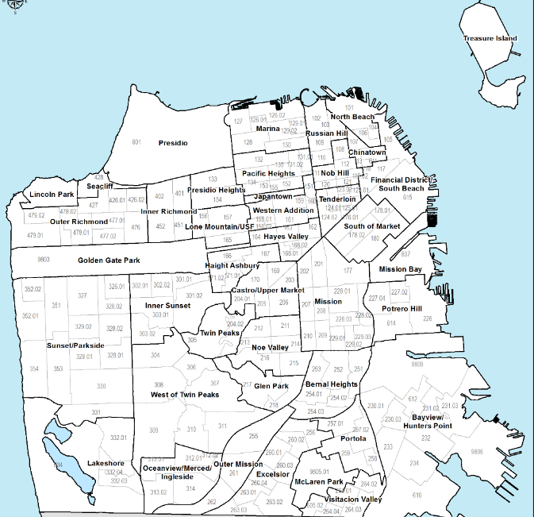

Neighborhood | % of Total Clients
1.
2.
3.
4.
5.
TOTAL | 100%

- Complete the table below for each program that would benefit from your project. Using the last column, show how each program is eligible under HUD's low-income beneficiary requirements. (We can fund the removal of architectural barriers without association to an eligible program.)
- % Determined Low-Income: A program that collects and verifies data on family size and income so that it is evident that the program predominantly serves low- and moderate-income clients. Enter the percentage of program beneficiaries that are low-income. (Refer to the table in Appendix A..)
Program Name | Program Description | # of Unduplicated Annual Clients | # of Low- and Moderate-Income Clients
1.
2.
3.
4.
5.

    - Complete the following table with estimated project timelines. You may add activities.
Activity | Start Date | End Date
- Establishing site control (e.g., owning, closing on a purchase, or establishing or extending a lease)
- Hiring an architect or other consultant
- Completion and approval of preliminary designs by the Mayor's Office on Disability (MOD)
- Applying for a building permit and license (if applicable)
- Project manager hired (if any)
- Capital Campaign consultant hired (if any)
- Bidding
- Construction
- Fundraising (if necessary)

Owner of Facility:
Facility/Site Size (in square feet):
Number of Stories:
Leased or Owned?
If leased, how long is the lease and how much time remains?
Total # of unduplicated clients served by program(s) within the facility:

- Organizational Capacity (Worth up to 25 points)
- Describe the construction training and experience of your staff. If you are already collaborating with a team of professional organizations and service providers, such as planners, architects, landscape architects, and engineers, and project managers. Name the team members and describe each of their professional qualifications and experience with similar projects.
- Provide a list of capital improvement projects that your staff have managed in the last 5 years. Include the scope of work, cost, funding sources and length of time to complete each project.
- Do you have a long-term asset management plan, including an operating and maintenance reserve, for the facility?
- If yes, describe how this grant request fits into the plan.
- If no, describe your efforts to develop a plan and ensure future resources for facility improvements.
- What percentage of our grant can you match? If you cannot meet our guidelines for matching funds (p.3), what is your fundraising plan?

- Advancing Racial Equity (worth up to 10 points) - MOHCD’s approach to racial equity is to reduce racial disparities in social and economic opportunity and ensure measurable outcomes for communities.
- The focus of this RFP is to provide funding for organizations that have a history of effectively serving the Asian Pacific Islander residents of San Francisco. Who are your target populations and how does your project address the disparities they face?
- What measurable outcomes will participants achieve through this project?

- Project Serves Populations Prioritized in the 2020 – 2024 Consolidated Plan (worth up to 10 points)
- List the populations that will be primarily served by the programs that operate in the facilities to be improved. Indicate with a check mark if those populations are prioritized in the 2020 – 2024 Consolidated Plan.
- What cultural competencies and practices do you have in place to provide equitable access to populations identified in the Consolidated Plan? (See Appendix B.)

Populations Served by the Facility to be Improved or Acquired | Population listed in MOHCD 2020 – 2024 Consolidated Plan ()

