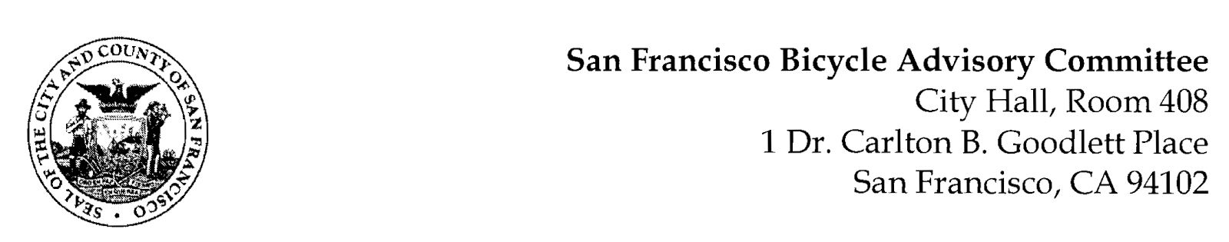

https://www.facebook.com/events/891192758972031/
MEETING AGENDA
Monday, January 23, 2023 at 6:30pm
Members: District 1 – Ms. Kristin Tieche- (Vice Chair), District 2 – Open, District 3 – Mr. Marc Brandt, District 4 – Ms. Jina Bartholomew, District 5 - Ms. Melyssa Mendoza (Secretary), District 6 – Ms. Mary Kay Chin, District 7 – Mr. Bert Hill (Chair), District 8 – Ms. Diane Serafini, District 9 – Brandon Powell, District 10 – Mr. Paul Wells, District 11 – Mr. Jeffrey Taliaferro
ORDER OF BUSINESS
- Roll Call – Determination of Quorum
- Ramaytush Ohlone Land Acknowledgement
- Approve Minutes – Monday, December 12, 2022
- Public Comment (Discussion Item)
The public may address the Committee on any matter within the jurisdiction of the Committee. This should not relate to any item on this agenda since the Committee will take public comment after it discusses and/or before voting on each agenda item. The Committee requests that each person limit him/herself to three minutes
- Committee Reports & Administrative Business (Information)
  - Chairman's Report
  - District Committee Member Reports
- Governmental/Organizational/Committee Reports (Discussion Item)
  - MTA Bicycle Program Report – Eillie Anzilotti
  - CTA Bicycle Project Funding – Aprile Smith
  - SF Bicycle Coalition – Rachel Clyde
  - BART Bicycle Advisory Task Force –Jon Spangler

- 13th Street Safety Project - (Presentation) Jennifer Wong, Streets Division, SFMTA – This is a proposal to improve traffic safety and comfort for all who travel on the 13th Street corridor. Specifically, it will reduce the number of conflicts between those who walk, bike, and operate motor vehicles along this corridor. It will also increase the connectivity of San Francisco’s bicycle network.
- Protocols within and Outside the Bicycle Advisory Committee – The BAC has traditionally acted informally, with loose interpretation in following the ‘Rules of Order’. We propose discussing the effectiveness of the BAC’s communication with the Board of Supervisors and how to improve our relationship and our degree of influence. We plan a discussion to reach an agreed consensus. Secondarily, California’s State of Emergency will expire on February 28, 2023. After that date, the historic process defined in the Brown Act will be followed. This will affect our ability to meet electronically, as well as our methods of Public Notice.
- Adjournment

