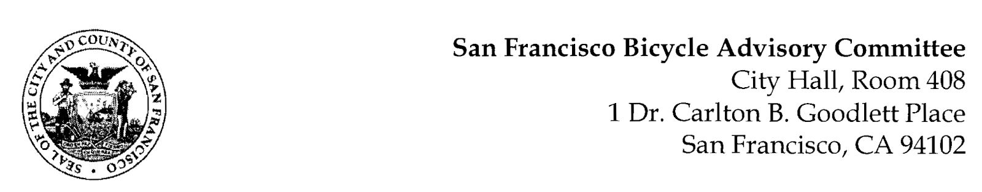

https://www.facebook.com/events/1185785648673013
MEETING AGENDA
Monday, October 24, 2022 at 6:30pm
Members: District 1 – Ms. Kristin Tieche- (Vice Chair), District 2 – Ms. Sarah Boudreau , District 3 – Mr. Marc Brandt, District 4 – Ms. Jina Bartholomew, District 5 - Ms. Melyssa Mendoza (Secretary), District 6 – Ms. Mary Kay Chin, District 7 – Mr. Bert Hill (Chair), District 8 – Ms. Diane Serafini, District 9 – Brandon Powell, District 10 – Mr. Paul Wells, District 11 – Mr. Jeffrey Taliaferro

ORDER OF BUSINESS
- Roll Call – Determination of Quorum
- Ramaytush Ohlone Land Acknowledgement
- Approve Minutes – Monday, September 26, 2022
- Public Comment (Discussion Item)
The public may address the Committee on any matter within the jurisdiction of the Committee. This should not relate to any item on this agenda since the Committee will take public comment after it discusses and/or before voting on each agenda item. The Committee requests that each person limit him/herself to three minutes
- Committee Reports & Administrative Business (Information)
  - Chairman's Report
  - District Committee Member Reports
- Governmental/Organizational/Committee Reports (Discussion Item)
  - MTA Bicycle Program Report – Eillie Anzilotti
  - CTA Bicycle Project Funding – Aprile Smith
  - SF Bicycle Coalition – Rachel Clyde
  - BART Bicycle Advisory Task Force –Jon Spangler
  - Bay Wheels – Neal Patel
- Improved Safety on Portola Blvd. (Presentation) Diane Serafini & Bert Hill – Over the last few years, the BAC has sent two Resolutions and a number of requests for an evaluation of what can be done regarding the extremely unsafe bike lane on the Eastbound side of Portola between St. Francis Circle and O’Shaughnessy Blvd. This request identifies the section of the roadway least likely to draw opposition, and may be the most potentially dangerous, Eastbound between Claremont and Miraloma Drive, where large trucks, RVs, and Campers are regularly parked, with their duals extending over the bike lane in an area with only one signalized intersection. There are no buildings with driveways along this portion of Portola, so no residents need the space for parking their cars. Vehicles traveling East in this section of Portola are often driving at near-freeway speeds. Sometimes the 48 and Sunday service MUNI buses pass with less than the required three foot clearance. It is also the steepest portion of Portola, so bicyclists are often traveling at about 5 mph, increasing the likelihood of fatality, given speed differentials in the 50 mph range. The Westbound side of this section of Portola is also free of residential homes, and is far less dangerous for cyclists, given the downhill speeds they can travel on Sharrows. Large trucks and campers can instead park along the ample space available in this direction.

- Sidewalk Detection for Motorized Scooters and Bicycles (Discussion) Jeff Taliaferro & Marc Brandt– Since the introduction of electrically motorized scooters and bicycles, there has been an increase of pedestrian injuries on sidewalks. Geofencing technology is used in some communities to identify and disable these devices as long as they are on a sidewalk. The Board of Supervisors recently passed a resolution requiring an MTA response. This is a proposal for a resolution to the MTA from the SF BAC.
- Adjournment

