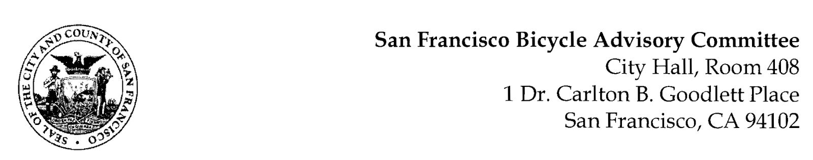

https://www.facebook.com/events/957710791606802/
MEETING AGENDA
Monday, April 25, 2022
Members: District 1 – Ms. Kristin Tieche- (Vice Chair), District 2 – Ms. Sarah Boudreau , District 3 – Mr. Marc Brandt, District 4 – Ms. Jina Bartholomew, District 5 - Ms. Melyssa Mendoza (Secretary), District 6 – Ms. Mary Kay Chin, District 7 – Mr. Bert Hill (Chair), District 8 – Ms. Diane Serafini, District 9 – Open, District 10 – Mr. Paul Wells, District 11 – Mr. Jeffrey Taliaferro

ORDER OF BUSINESS
- Roll Call – Determination of Quorum
- Ramaytush Ohlone Land Acknowledgement
- Approve Minutes – Monday, March 28, 2022
- Public Comment (Discussion Item)
The public may address the Committee on any matter within the jurisdiction of the Committee. This should not relate to any item on this agenda since the Committee will take public comment after it discusses and/or before voting on each agenda item. The Committee requests that each person limit him/herself to three minutes
- Committee Reports & Administrative Business (Information)
  - Chairman's Report
  - District Committee Member Reports
- Governmental/Organizational/Committee Reports (Discussion Item)
  - MTA Bicycle Program Report – Eillie Anzilotti (she, her)
  - SF Bicycle Coalition – (Open)
  - SFPD Traffic Division – Lt. Bill Conley (Acting Captain) Excused
  - Public Works - Open
  - BART Bicycle Advisory Task Force –Rick Goldman & Tyler Morris
  - Bay Wheels – Neal Patel (No Report)
- Lake Merced Quick Build Project (Presentation) Shayda Haghgoo, SFMTA – Lake Merced is on the City’s High Injury Network. One third of incidents cite unsafe speeds as a primary factor in collisions. Guided by the Lake Merced Safety Community-based Transportation Plan, Lake Merced Bikeway Feasibility Study, and the Vision Zero Quick-Build Program, the MTA is working to improve traffic safety for all travelers to and along Lake Merced Boulevard.
- Adjournment

