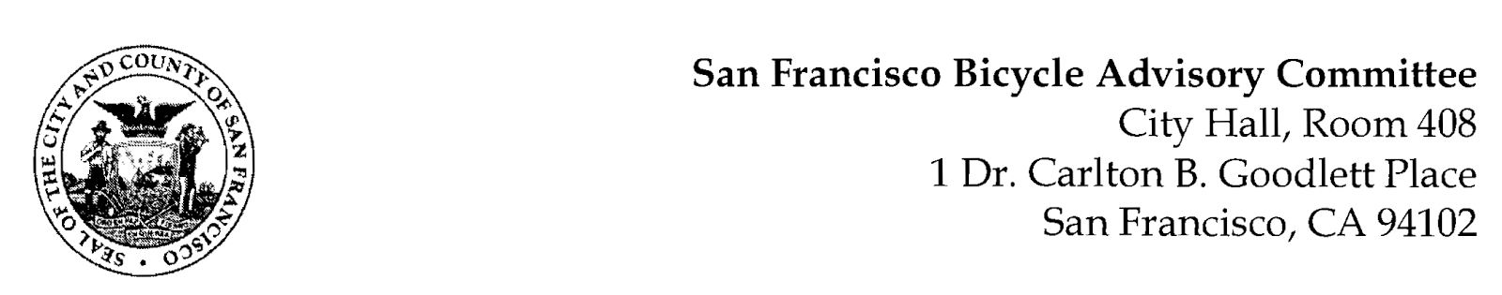

Facebook event link: https://fb.me/e/1yY1oXTDO
SPECIAL MEETING AGENDA
Saturday, April 2, 2022
Members: District 1 – Ms. Kristin Tieche- (Vice Chair), District 2 – Ms. Sarah Boudreau , District 3 – Mr. Marc Brandt, District 4 – Ms. Jina Bartholomew, District 5 - Ms. Melyssa Mendoza (Secretary), District 6 – Ms. Mary Kay Chin, District 7 – Mr. Bert Hill (Chair), District 8 – Ms. Diane Serafini, District 9 – Open, District 10 – Mr. Paul Wells, District 11 – Mr. Jeffrey Taliaferro

ORDER OF BUSINESS
- Roll Call – Determination of Quorum
- Community of Interest letter – Discuss and vote to approve Community of Interest letter to send as the BAC to the San Francisco Redistricting Taskforce.
- Adjournment

