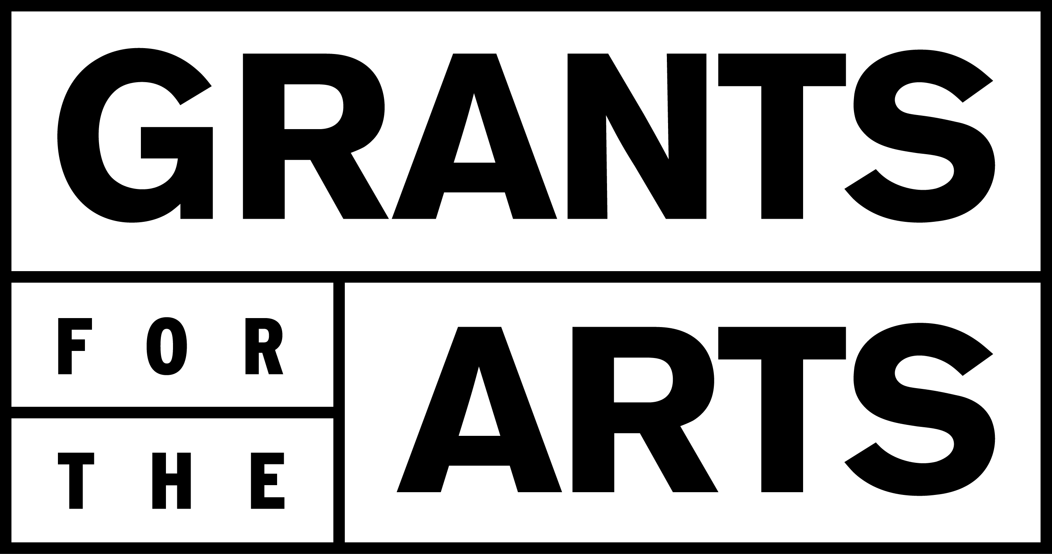**Grantee Name: ________________________**

**Contract ID: ________________________**

**Reporting Period: July 1, 2024 – June 30, 2025**

**Appendix F- Mid-Cycle Grantee Reporting Sample Form\***

**NEW REQUIREMENT: All FY25 GFTA grantees are required to submit a Mid-Cycle Grantee Reporting Form in order to be eligible to receive their FY26 GFTA grant.**  The reporting form will cover the period from July 1, 2024 to June 30, 2025.

*Reporting forms must be submitted online. GFTA will email all grantees a link to the online form at a later date.

**Mid-Cycle Grantee Reporting Form Questions**

*Please answer the following questions in the online form:*

**1. Were there any changes between your original grant plan and the work that actually took place? Were there major budget revisions, key personnel changes, and/or changes in scope? If yes, please describe and explain the changes made during this budget period.** (3000 characters/ 500 words max)

**2. Describe how GFTA funds have supported your organization in promoting the diverse and unique communities of San Francisco over the last fiscal year (July 1, 2024 – June 30, 2025).** (1500 characters/ 250 words max)

**3. Economic Impact\***

* Total FY25 in-person programs/services
* Total FY25 in-person programs/services in San Francisco
* Total FY25 attendance for your in-person programs/services in San Francisco
* Total FY25 FTE
* Total FY25 FTE for employees that live in San Francisco
* Total FY25 paid artists featured in your programming
* Total FY25 paid artists featured in your programming that live in San Francisco

Please use the following information as a guide:

* An employee is a person who is paid wages or a salary to perform services
* FTE, or full-time equivalent, is a unit of measurement that represents the total number of full-time hours an organization's employees work. One FTE can be one full-time employee, two half-time employees, four employees who work quarter-time, etc.
* FTE = total # of all employee hours worked per year divided by total working hours per year. Example: 2 FTE = 4160 employee hours worked / 2080 working hours per year

*\*If there are no changes in the number of programs, FTE count, and/or artist count from your application, you may indicate “no change.”*

**4. Budget Snapshot + Financial Statement Attachment**

* Please provide your budget and actuals for your organization’s most recently completed fiscal year.
  + *Note for fiscally sponsored organizations: This budget must come from the grantee organization, not the fiscal sponsor.*

|  |  |  |
| --- | --- | --- |
|  | Budget | Actuals |
| **REVENUE:** |  |  |
| Contributed: (Board Contributions, Individual Contributions, Foundation Grants, Government Grants) |  |  |
| Earned: (Ticket Sales, Touring Fees, Merch Sales, Membership Dues, Workshop Fees, Special Events, Rental Income) |  |  |
| In-kind |  |  |
| Miscellaneous |  |  |
| **EXPENSES:** |  |  |
| Personnel: (Salaries, Benefits/Taxes/Fees, Professional Development, Workers Comp) |  |  |
| Programming (Production & Events): (Artists and Performers – Non-Salaried, Event Venue Rental, Event Travel-Related Expenses, Program-Related Materials, Supplies, and Equipment) |  |  |
| Operating: (Accounting, Bookkeeping & Auditing, Bank Fees, Insurance, Legal Services, Marketing & Advertising, Payroll, Rent & Facilities, Travel, and Utilities) |  |  |
| Miscellaneous |  |  |

* (*optional*) Did your organization undergo any significant financial changes over your last fiscal year? If yes, please provide explanation. (1500 characters/ 250 words max)
* *(optional)* If your organization’s actuals show a deficit, please explain why and describe the steps you are taking to reduce it. (1500 characters/ 250 words max)
* Attach a financial statement (audited or unaudited) of your organization’s most recently completed fiscal year.

Audited financial statements generally include:

* + Statement of Financial Position (Balance Sheet)
  + Statement of Activities (Income Statement)
  + Cash Flow Statement
  + Statement of Functional Expenses

Unaudited financial statements are prepared by your organization without the assistance of an external auditor. These reports are used for internally monitoring and for informing the Board of Directors about the financial status of the organization.

**5. Photo Documentation:**

* Provide at least one image of key programming/services completed during the reporting period (July 1, 2024 – June 30, 2025).
* These images may be used for GFTA marketing purposes, so only provide images you have the rights and permission to use – and to authorize GFTA to use - including, but not limited to, all intellectual property rights (copyright, trademark, etc.) and permission from any individual whose image is used.
  + Photo caption (if any):
  + Photographer credit (if any):