Hospital Operations & Patient Care Report
Presented to the Health Commission – ZSFG on June 27, 2023
ZSFG Executive Team Report
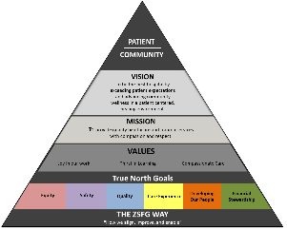
Report Updates

Data Updates
s

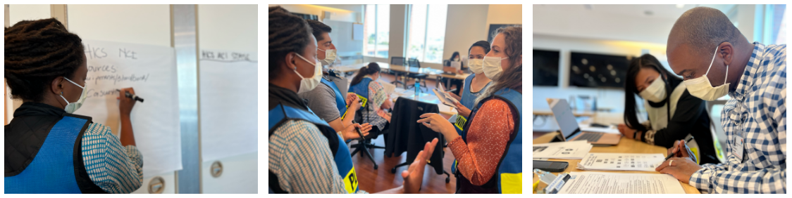
On June 8th ZSFG participated in a Mass Casualty Incident (MCI) functional exercise with DPH, DEM, SFFD, EMSA, OCME and nine other local hospitals including UCSF, CPMC, KAISER, VA and others. The MCI exercise is part of an annual series of tabletop, functional and full-scale exercises done city-wide and with the city's Public Safety agencies and other local hospitals as needed.

An MCI functional exercise aims to help ZSFG practice handling a surge of trauma patients after a mass incident occurs. This month’s particular drill centered around a fictional scenario that included a bombing and shooting during a city event that drew over 100,000 victims. Throughout the exercise, our hospital managed a surge of trauma patients; activated the Hospital Incident Command System (HICS); tracked and triaged patients by working with local hospitals and deploying resources such as staff and equipment; and identified various communication channels to provide information to staff and to the public such as media interviews, press conferences, press releases, Everbridge notifications and social media.

Practices like these will keep ZSFG ready and resilient in times of need. Many thanks to DPH's Public Health Emergency Preparedness and Response (PHEPR) for organizing this exercise and to Lann Wilder, Chauncey Jackson, and Jeff Schmidt , for leading and coordinating our emergency efforts at ZSFG.
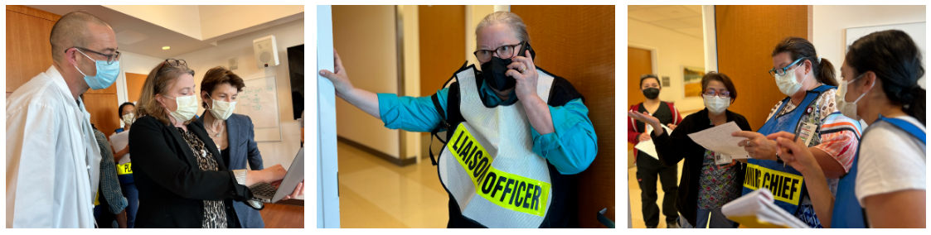

From June 5th through June 8th, four surveyors from the California Department of Public Health conducted our annual 4A-Skilled Nursing Facility (SNF) re-certification survey! This survey allowed 4A-SNF to showcase the high-quality care they provide to their residents every day. Both the 4A-SNF and Food and Nutrition Services (FNS) teams demonstrated incredible collaboration and teamwork. The surveyors complimented the staff on their engagement and dedication to their patients.

Congratulations to all our 4A-SNF and FNS staff who participated in this annual re-certification survey! A special thanks to Brianna Stein, Edna Paredes, Kathy Ballou, Suzette DeJesus, Katie Jackson, Christine Struble and Michael Jenkins (along with their teams) for their partnership during this survey!

On May 31st, ZSFG hosted its first Asian American & Pacific Islander (AAPI) Heritage Month staff celebration at the Wellness Center, sponsored by the Department of Diversity, Equity, and Inclusion (DEI) and the Staff Experience team. Employees from across the hospital came together to celebrate the contributions of staff from diverse AAPI cultures. Rosaly Ferrer, Nursing Director for Specialty Clinics, hosted the program and provided opening remarks. Several staff from Asian American or Pacific Islander backgrounds shared their stories and passion for their work at ZSFG in pre-recorded interviews.

The videos showcased the following diverse voices:
- Amanda Huynh, Medical Records Technician – Quality Management
- Joy Kwong, Nurse Manager – Operating Room
- Joseph Nauer, Stores & Equipment Asst Supervisor – Materials Management
- Shilu Ramchand, Nurse Manager – NICU and Pediatrics
- Jenny Tran, Healthcare Analyst – Quality Management
- Maria Velasco, Nurse Practitioner – Neurosurgery
- Song Yang, Senior Administrative Analyst – Finance

Performances included Thai traditional dance by Pat Reynolds, IT Specialist, and Hawaiian songs from J.D. Puli from Hawaiian Royalty Music. Dr. Susan Ehrlich provided closing remarks, thanking staff for their rich contributions to ZSFG patients and community. Guests enjoyed a delicious spread of Vietnamese sandwiches and salads, Thai desserts, and fruit. Our deepest appreciation to Sophia Lai, Khadijah Grant, Eileen Conklin, and Gretel Chuquipul for organizing this fun and enriching event.
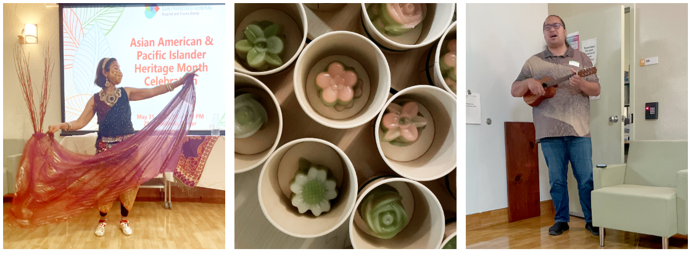

This past month, ZSFG celebrated the following healthcare recognitions in honor of our staff and the incredible work they do every single day!

Annual Employee Celebration
On June 13th, ZSFG honored and recognized the employees who have been with the hospital from 10 to 45 years at the online 2022 Employee Celebration and Recognition Event and via the Building 25 mezzanine display. During the virtual celebration, members of our Executive Team including Dr. Susan Ehrlich, Chief Executive Officer, Dr. Elena Fuentes-Afflick, UCSF Vice Dean, Dr. Lisa Winston, Chief of Staff, Dr. Jim Marks, Chief of Performance Excellence, Andrea Turner, Chief Operating Officer, and Christine Falvey, Chief Communications Officer, honored and congratulated our 517 honorees whom together have served our communtiy 8435 years!
Additionally, every year, the ZSFG Executive Team recognizes two individuals who have worked at ZSFG for 30 years or more with the Executive Administrator’s award. This year those two individuals were Bilal Chaney and Dr. Paul Garcia.
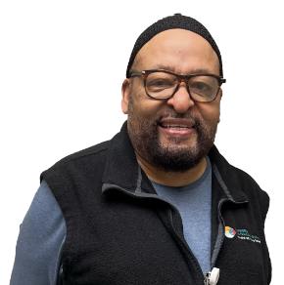
Mr. Chaney has been a friendly face in Radiology for more than 30 years and is a champion for diversity efforts on our campus. He is kind, welcoming, and very constructive. He is persistent and persuasive and has a welcome smile for everyone he greets. Over the years, Bilal has supported our staff and patients, bringing in new programs and has taken on many roles in his position as Department of Equity and Inclusion Lead for Radiology. With his guidance, the Radiology Department is consistently supporting equity at ZSFG.

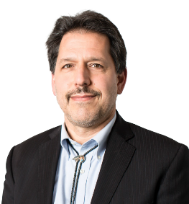
Dr. Garcia has been with the Department of Neurology and ZSFG for more than 30 years. A nationally recognized neurologist, he is the director of the Clinical Epilepsy Services at UCSF Medical Center. His university service is focused on assuring opportunity for students and faculty across the campus. He is the go-to person for complex seizures and there are many patients who have benefitted from his expertise. He is a humble, hard-working, and kind person. Dr. Garcia's tremendous leadership and commitment to ZSFG assures, year after year, that our Neurology Service continues to bring world-class medical care to those who need it most.

Our deepest gratitude to Mr. Chaney and Dr. Garcia for their many years of service! ZSFG would also like to thank and congratulate all the honorees for their incredible work and commitment to this organization, our patients and community. Our staff is our greatest asset, and we would not be the remarkable institution we are today without the amazing work they all do every day.

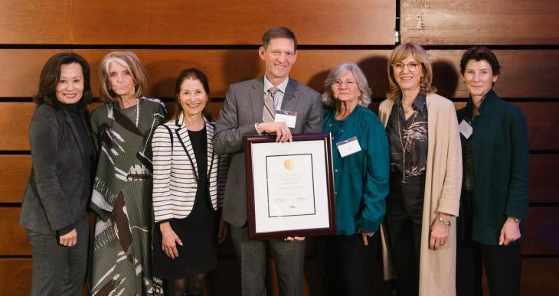
Congratulations Dr. Theodore Miclau!
Dr. Theodore Miclau, MD has been appointed as the Orthopedic Trauma Institute International Chair! As holder of the chair, Dr. Miclau will continue to support the research, teaching and clinical activities related to international orthopaedic trauma activities for the Department of Orthopaedic Surgery at ZSFG. Dr. Miclau is the first recipient of the Orthopaedic Trauma Institute International Chair, which is the first-of-its-kind in the United States, and the first endowed chair at the ZSFG Department of Orthopaedic Surgery.

National Infrastructure Week
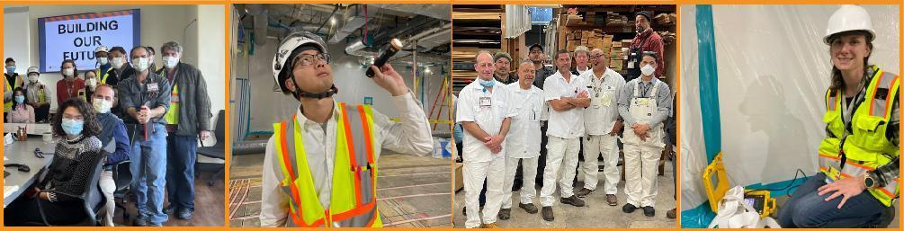
The week of May 15th was National Infrastructure week! Led by Terry Saltz, the capital projects and facilities teams serve as the backbone of all our hospital operations. From opening a new, state-of-the-art main hospital building in 2016 to making all the necessary seismic upgrades and clinic renovations to our urgent care and outpatient services building, the capital team is preparing our hospital for a long-lasting future. Thanks to our top-notch team of project managers, engineers and inspectors for continually improving our hospital, which helps meet the growing needs of our community.

From maintaining our beautiful campus gardens to keeping the lights on and the water pumping, our on-call 24/7/365 facilities team makes sure that everything runs smoothly from day to day. Much appreciation goes to the maintenance crews, gardeners, artisans, carpenters, electricians, painters, locksmiths, plumbers, steamfitters, stationary engineers, utility workers and everyone else who maintains our incredible campus. Their work helps create a positive experience for our patients!

2023 EMS Week Awardee
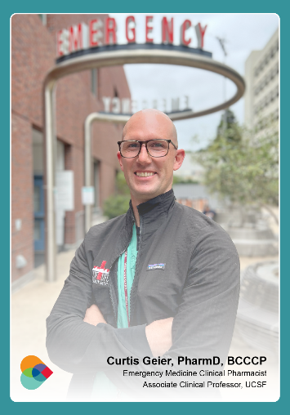
During 2023's #EMSWeek, the City's Department of Emergency Management (DEM) and Emergency Medical Services Agency (EMSA) awarded the 2023 EMS Hospital Provider Award to Dr. Curtis Geier, PharmD, BCCCP – an Emergency Medicine Clinical Pharmacist in the Emergency Department here at ZSFG.

Dr. Geier was recognized for ensuring EMS initiatives, protocols, and medications are accurate and evidence based and for developing protocol changes related to medication shortages and formulary changes. Most recently, he helped develop a major overhaul of EMS epinephrine protocols, to ensure both epinephrine and midazolam were available to EMS, two essential medications they use in their EMS response.

He shares, “I love working collaboratively with our nurses, MEAs, social workers and physicians to care for our amazing patient population. It's rewarding to work as part of this team truly focusing on not just the emergency that brought someone here, but also the whole patient and the other determinants that may impact their health outcomes both in the short and long term. I am honored to be involved in the training of our amazing pharmacy and physician residents and students. I mostly just appreciate all of the staff and leadership for their support and letting me work in this amazing ED.”

Congratulations and thank you, Dr. Curtis Geier!

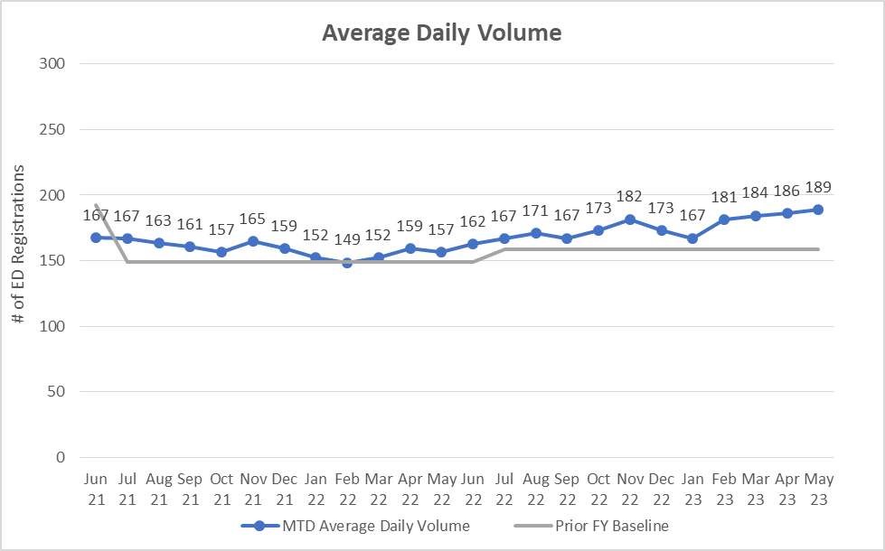
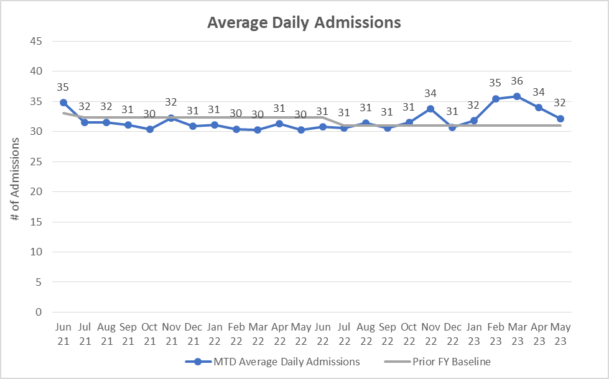
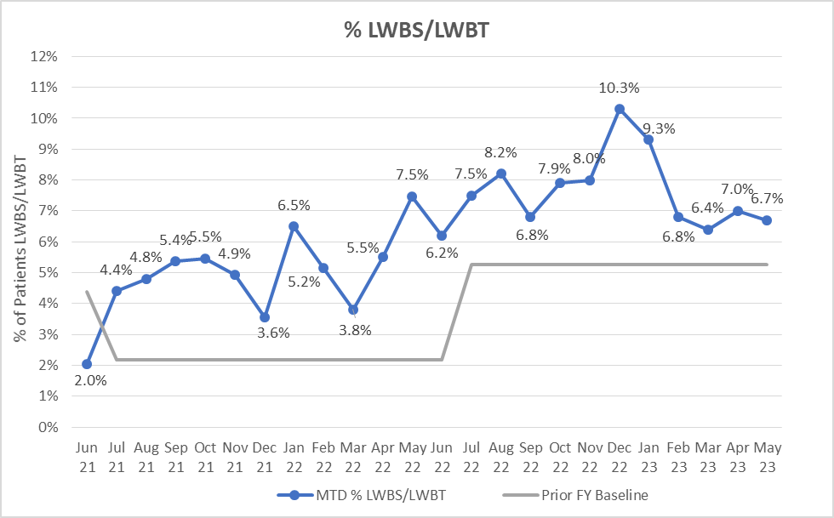

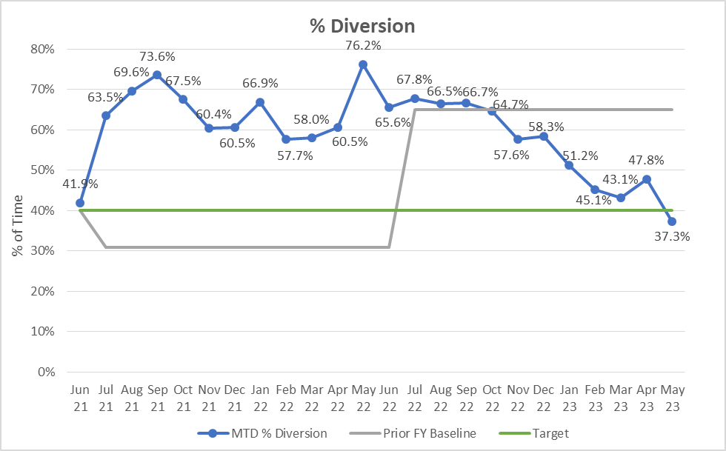

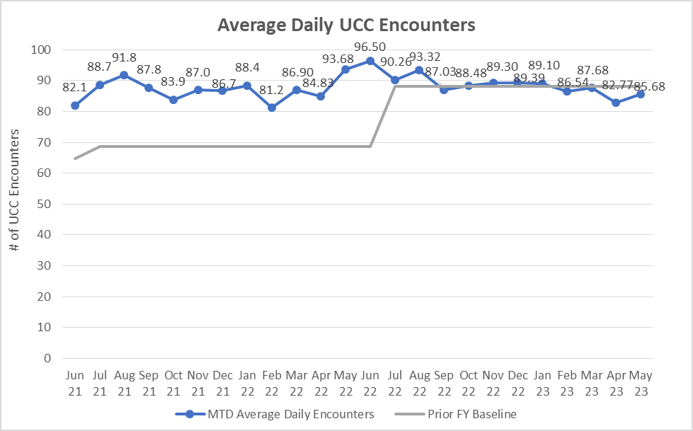
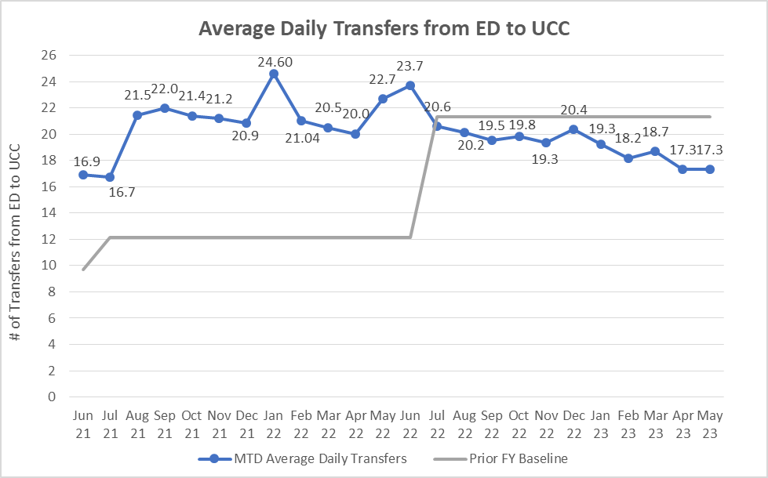
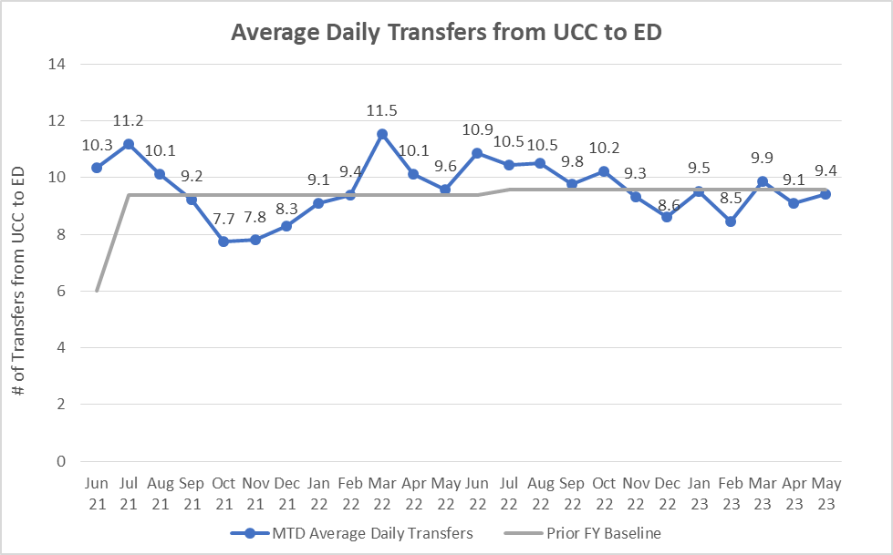

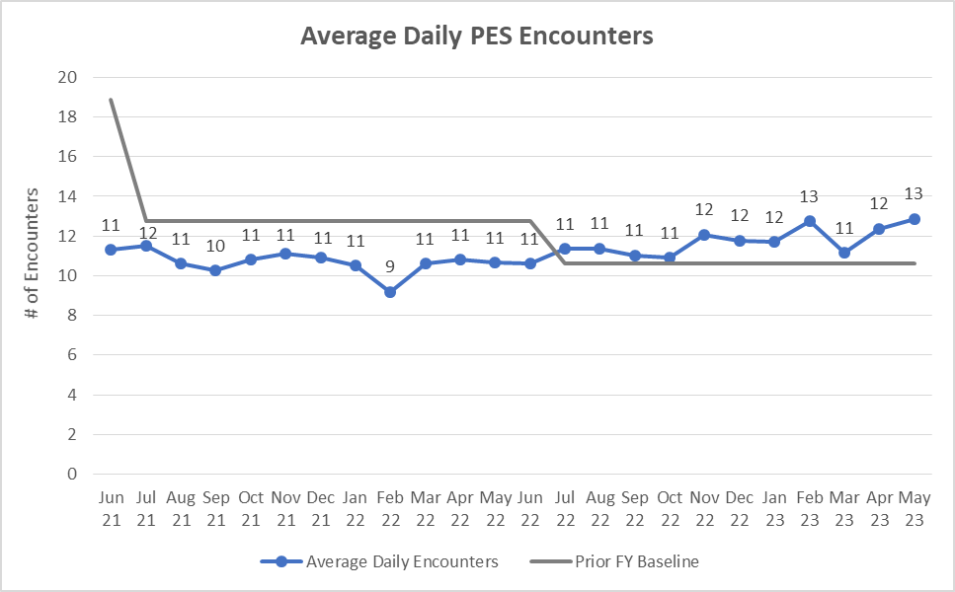
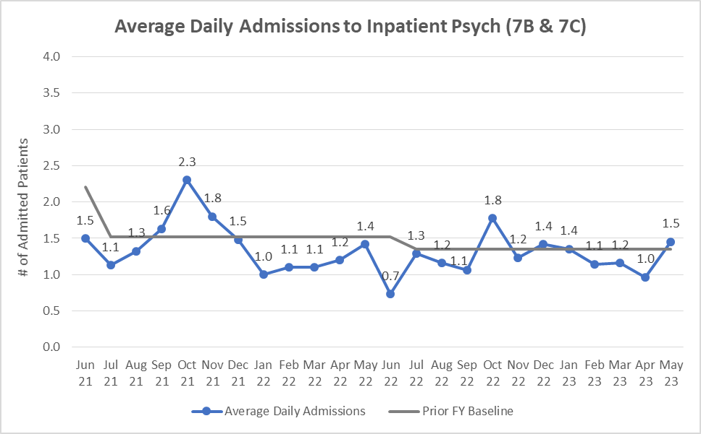
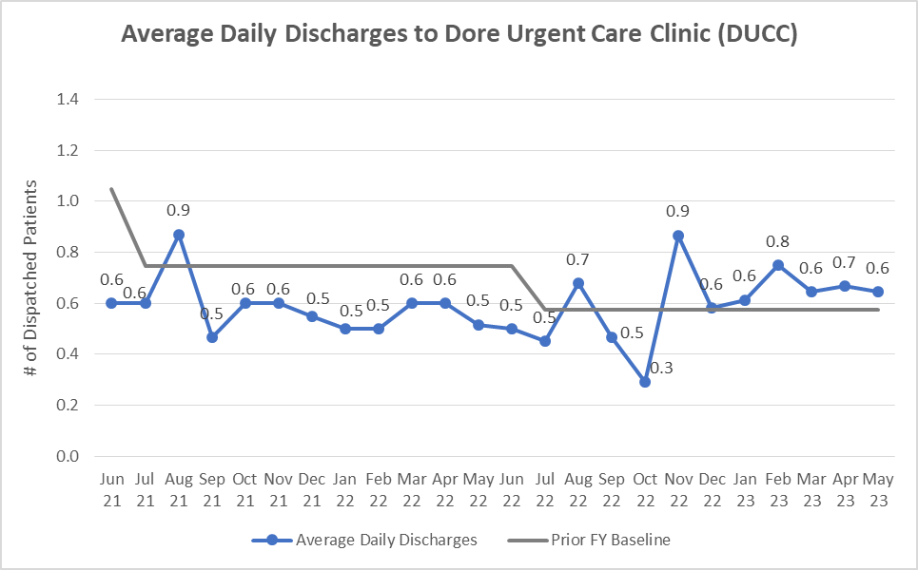
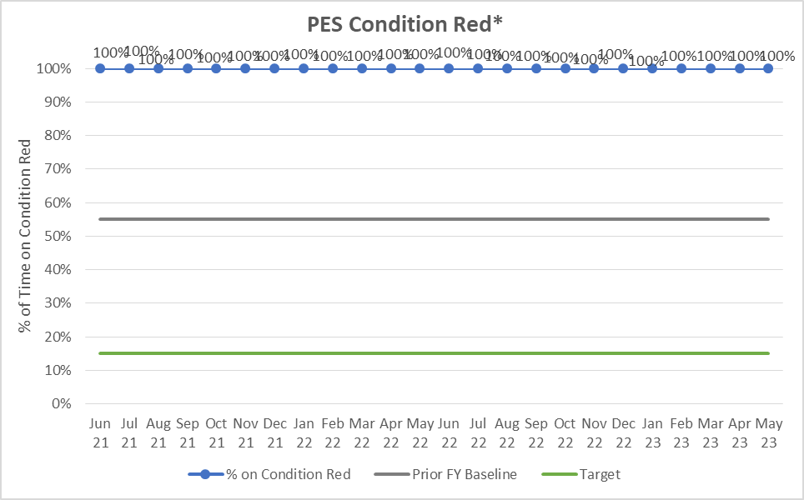
*We are using condition red as an external communication tool to signal that patients can not directly come to PES. They must be cleared by ED first.

MEDICAL/SURGICAL
Average Daily Census of Medical/Surgical was 187.19 which is 109.47% of budgeted staffed beds and 101.74% of physical capacity. 34.50% of the Medical/Surgical days were lower level of care days: 8.91% administrative and 25.59% decertified/non-reimbursed days.
INTENSIVE CARE UNIT (ICU)
Average Daily Census of ICU was 30.55which is 109.10% of budgeted staffed beds and 52.67% of physical capacity of the hospital.
MATERNAL CHILD HEALTH (MCH)
Average Daily Census of MCH was 29.39 which is 97.96% of budgeted staffed beds and 62.35% of physical capacity of the hospital.
ACUTE PSYCHIATRY
Average Daily Census for Psychiatry beds, excluding 7L, was 41.77, which is 94.94% of budgeted staffed beds and 62.35% of physical capacity (7B & 7C). Average Daily Census for 7L was 5.90, which is 84.33% of budgeted staffed beds (n=7) and 49.19% of physical capacity (n=12). Utilization Review data shows 100.39% non-acute days (23.01% administrative and 77.37% non-reimbursed).
4A SKILLED NURSING UNIT
Average Daily Census for our skilled nursing unit was 27.90, which is 99.65% of our budgeted staffed beds and 93.01% of physical capacity.

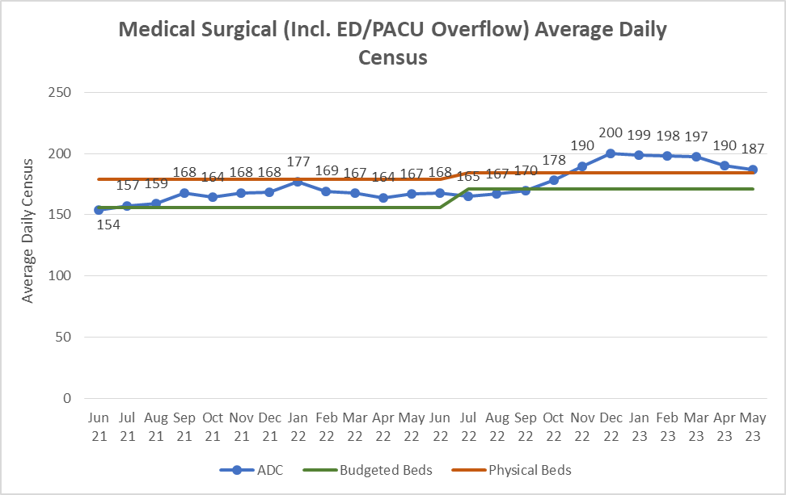

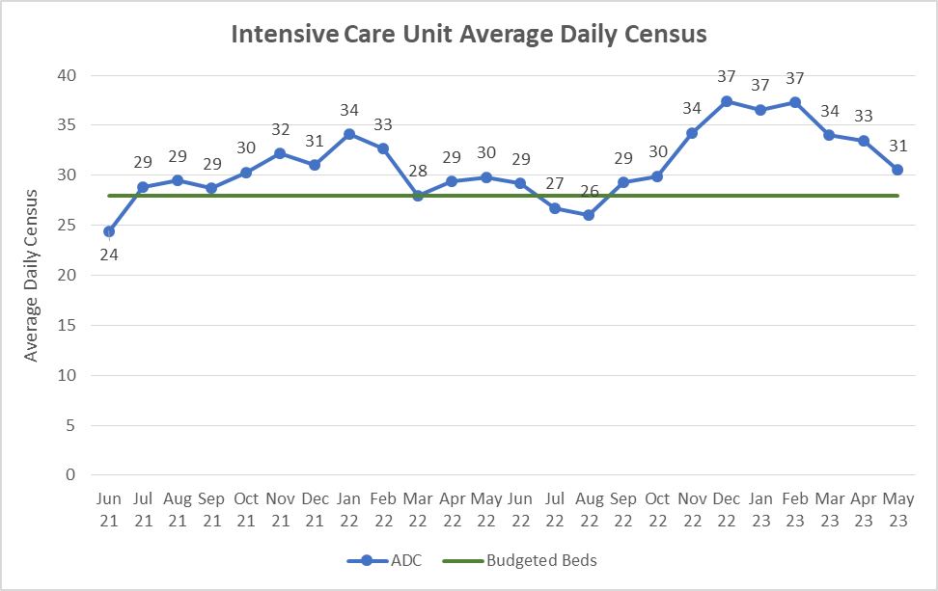
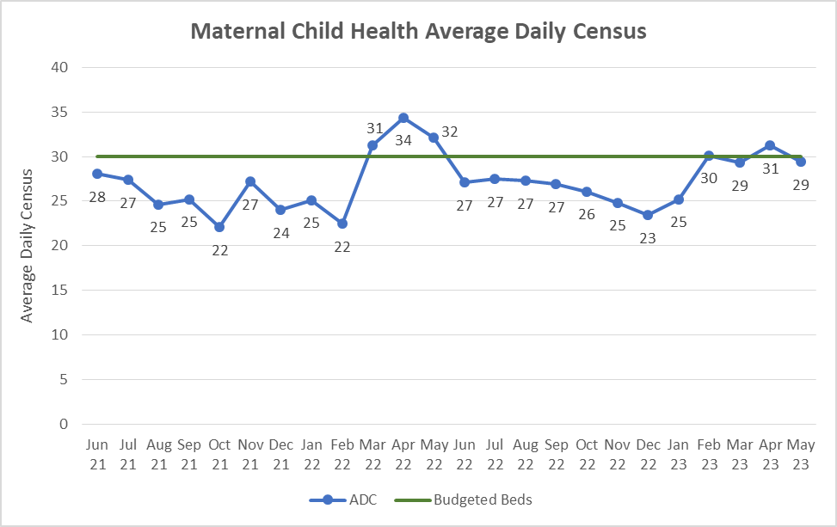

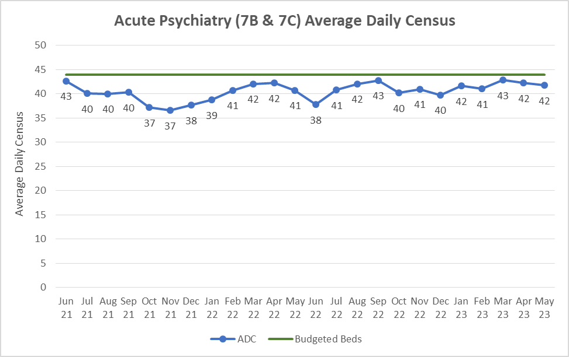
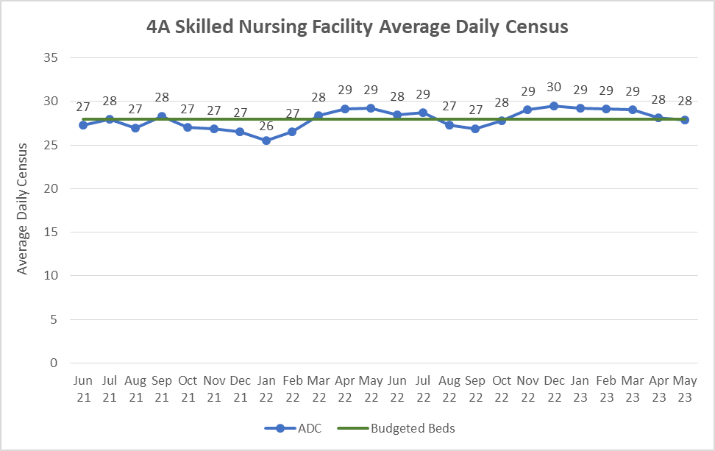

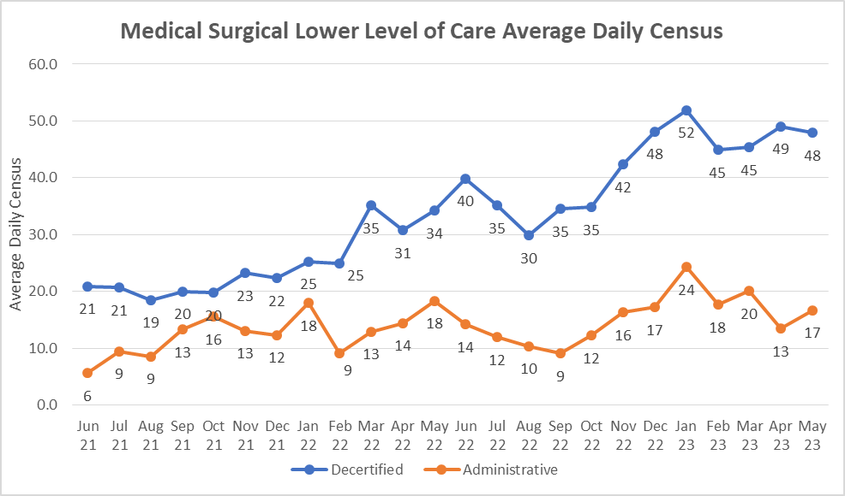
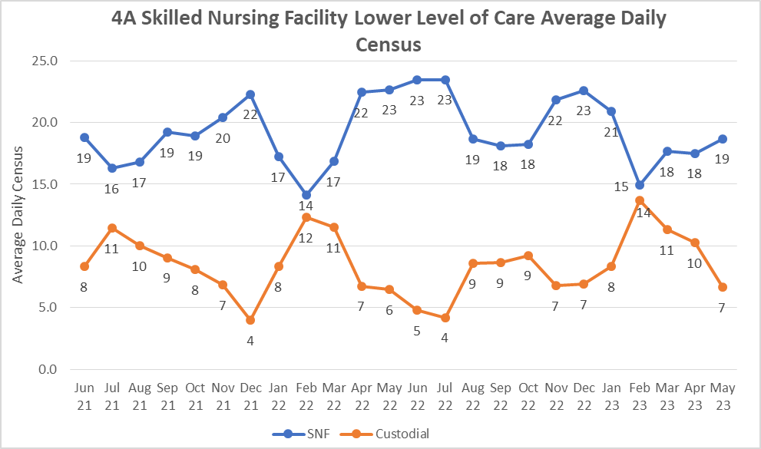

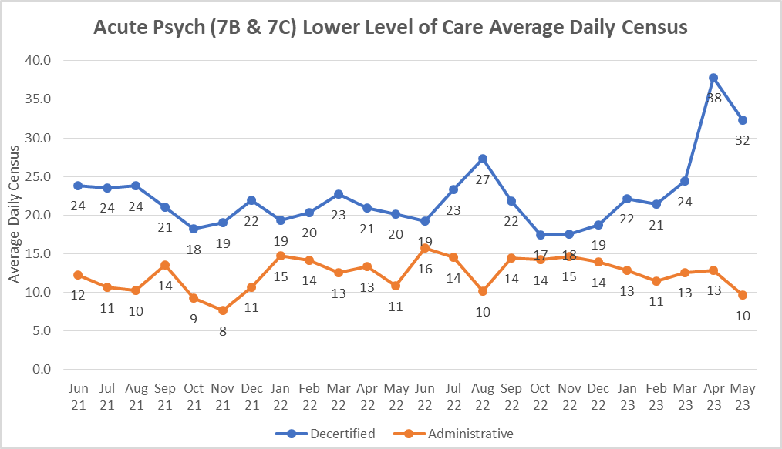

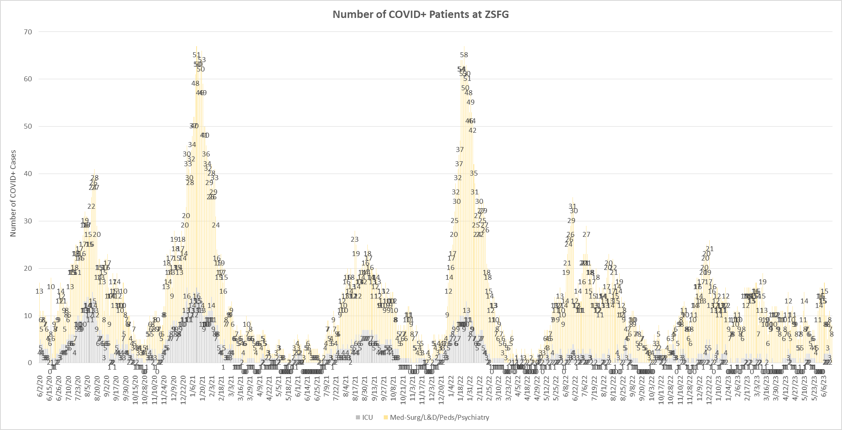

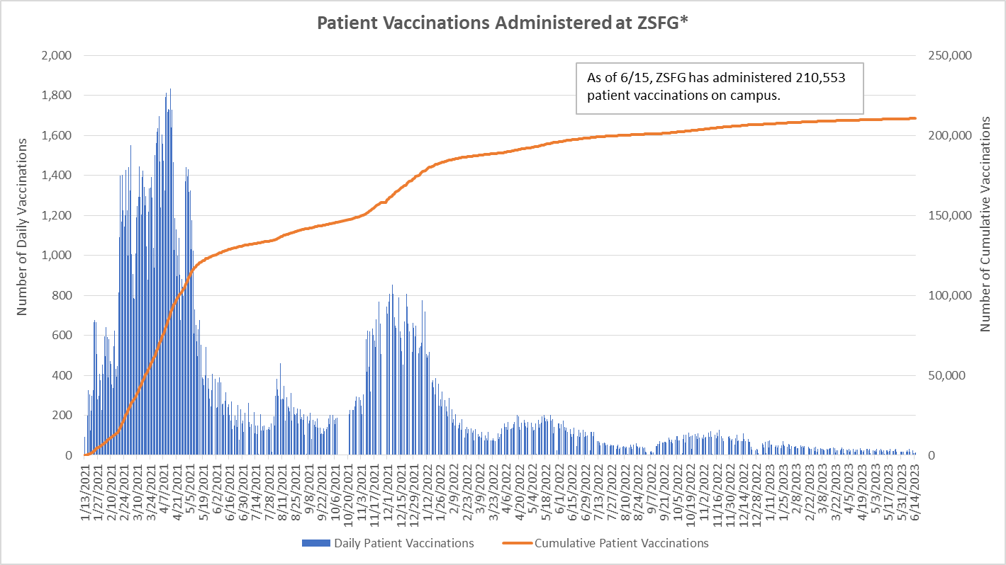
*Includes network-wide patients and members of the community.

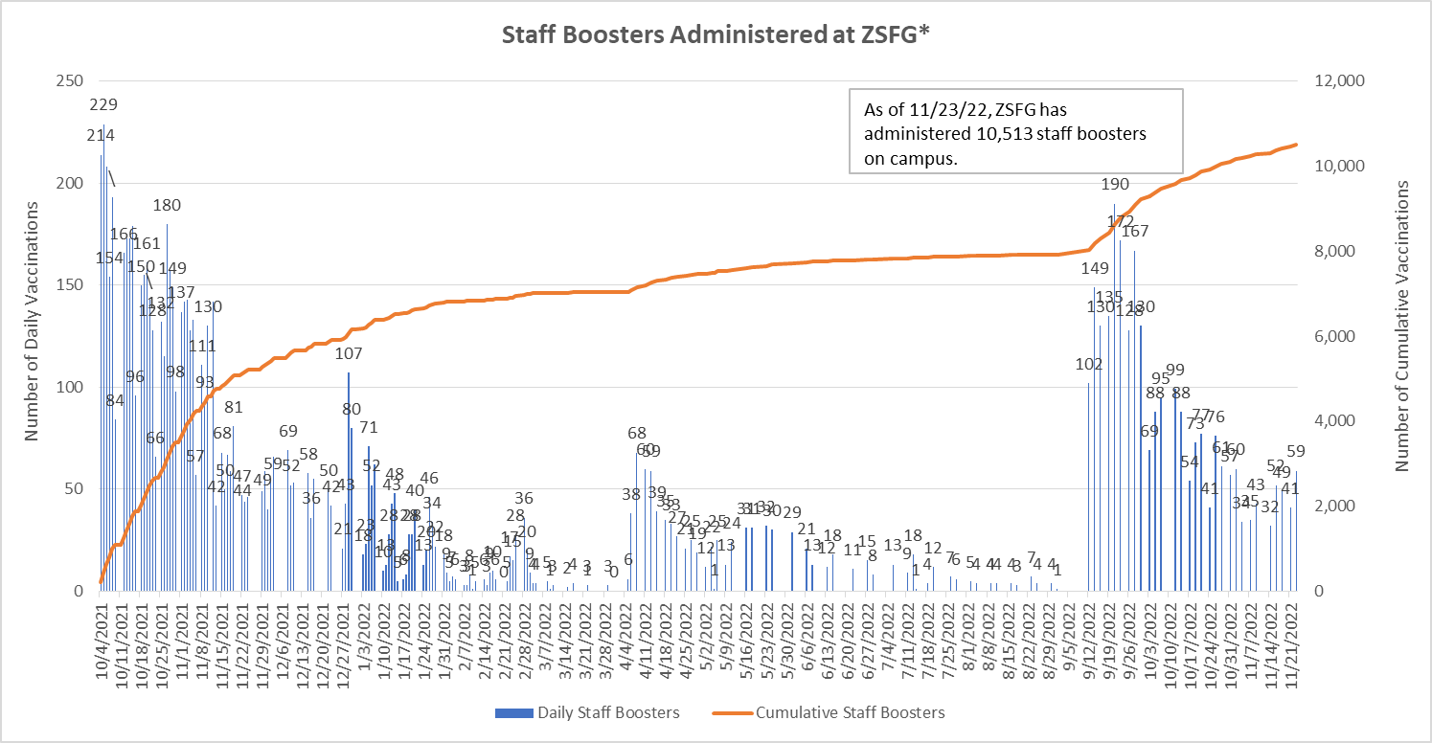
*Staff Booster data is currently unavailable.

As of June 15, 2023, 4,596 ZSFG employees have tested positive for COVID-19.
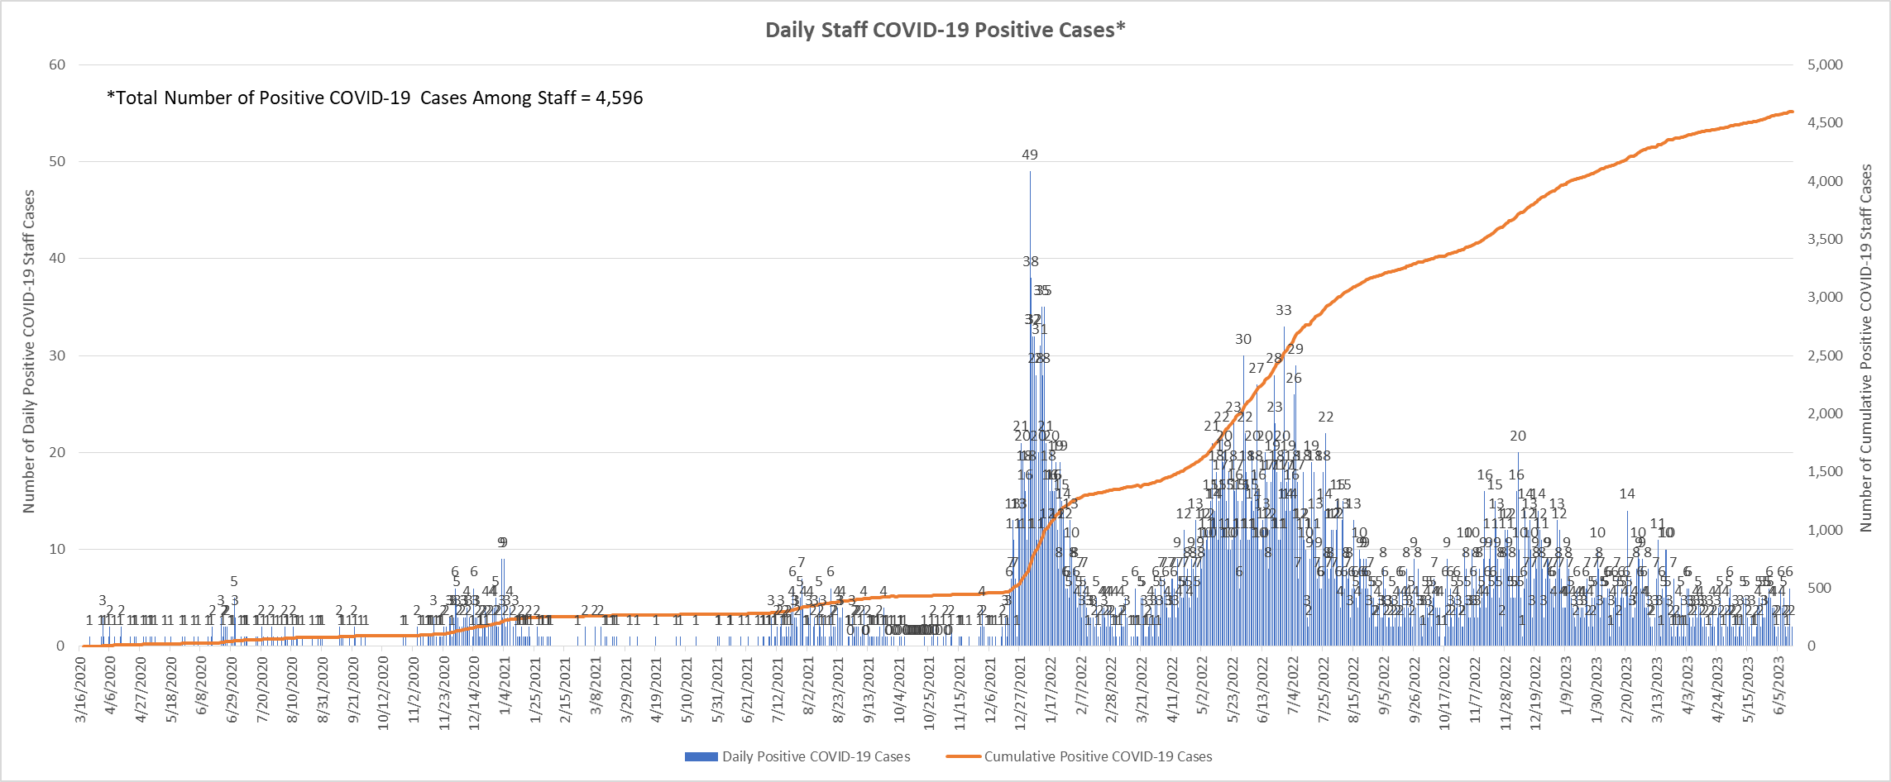

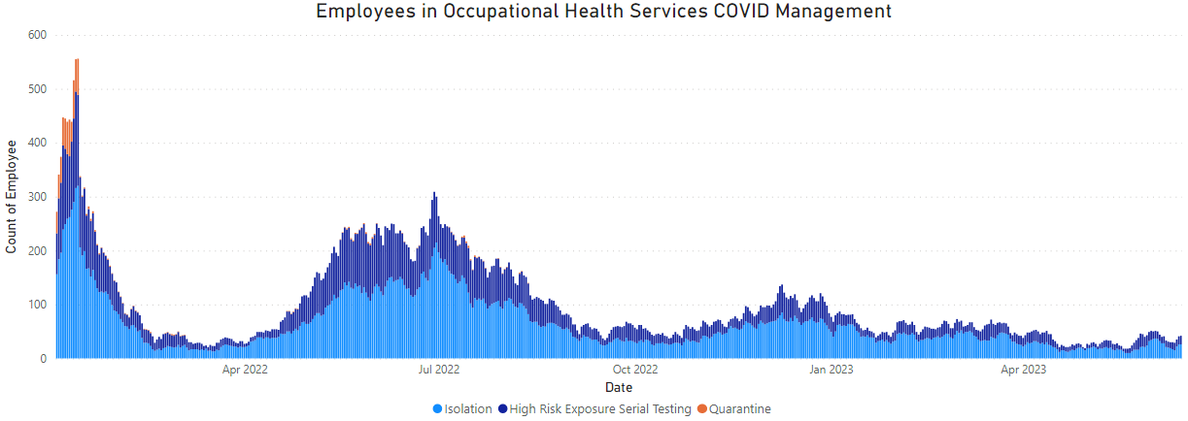

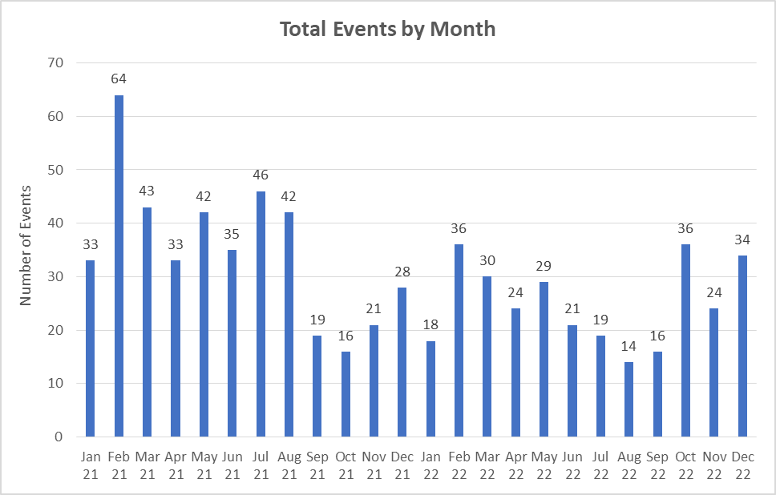
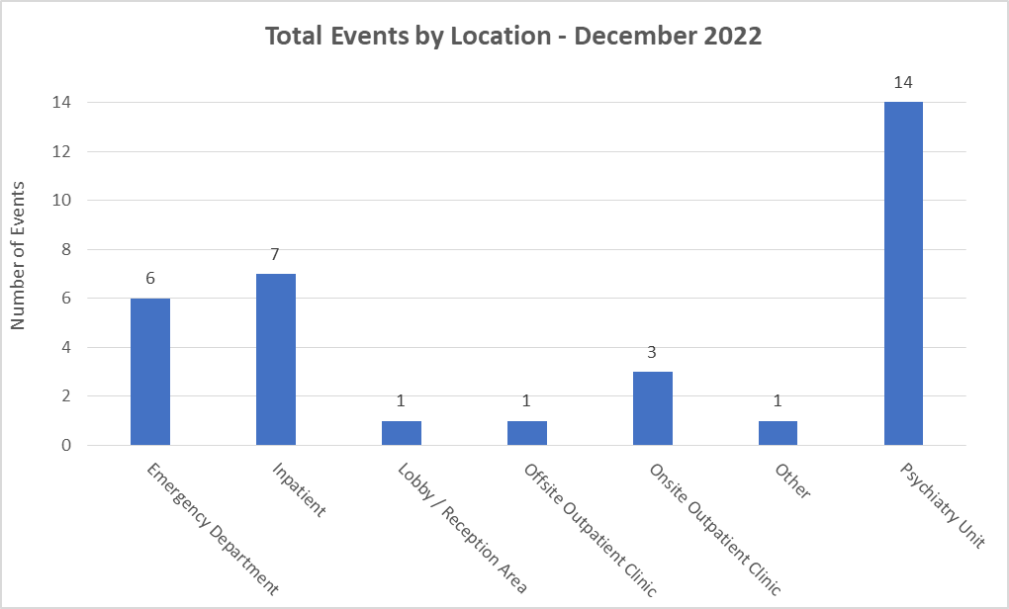
*Workplace Violence data is currently unavailable post-SAFE system go-live.

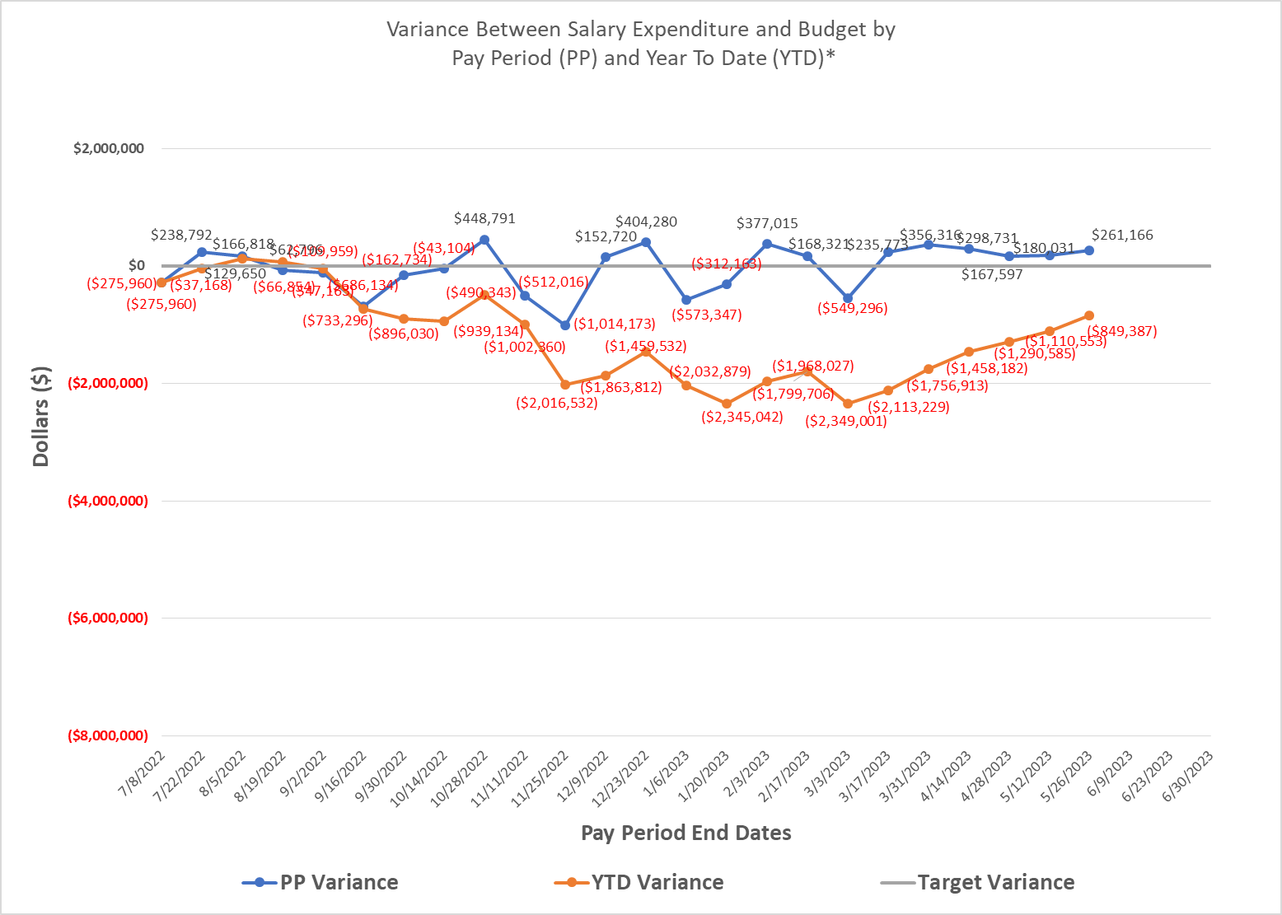
*Please note that COVID-19 costs are now a part of ZSFG operations and budget.

